MISSING CAT
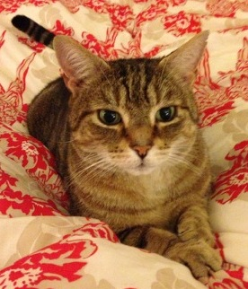
Billy has been missing since Monday morning (04th March 2013), it is very unusual for him not to come in at night.
He is a male tabby with a white chin, and is missing at least 2 of his sharp canine teeth from previous battles!
Billy is micro-chipped so if found please either contact a very worried owner Nikki on 07795 242827 or the local vets. Billy lives at 22 Hop Garden, Zebon Copse, Church Crookham.
Please could you check your gardens/garages/sheds to see if Billy is anywhere to be seen. Please help us find this friendly and loveable rogue.

